|  |
| --- |
|  |
| VACCINATION REGISTRATION SYSTEM |
|  |
|  |

|  |
| --- |
|  |

* RA2111003010227 MANAS GOEL
* RA2111003010242 HARDIKA
* RA2111003010243 SHIVANSH
* RA2111003010244 JIIYAA JAISWAL

OBJECTIVE:

To create a file with database of vaccinated citizens with their prefferred vaccine

PROBLEM DEFINITION:

India have 2nd highest population in world and to create a manual file of this much population is not at all a easy thing.so create a

C program to create a file and store the database of vaccinated population with the vaccination they used in that file.

FLOWCHART

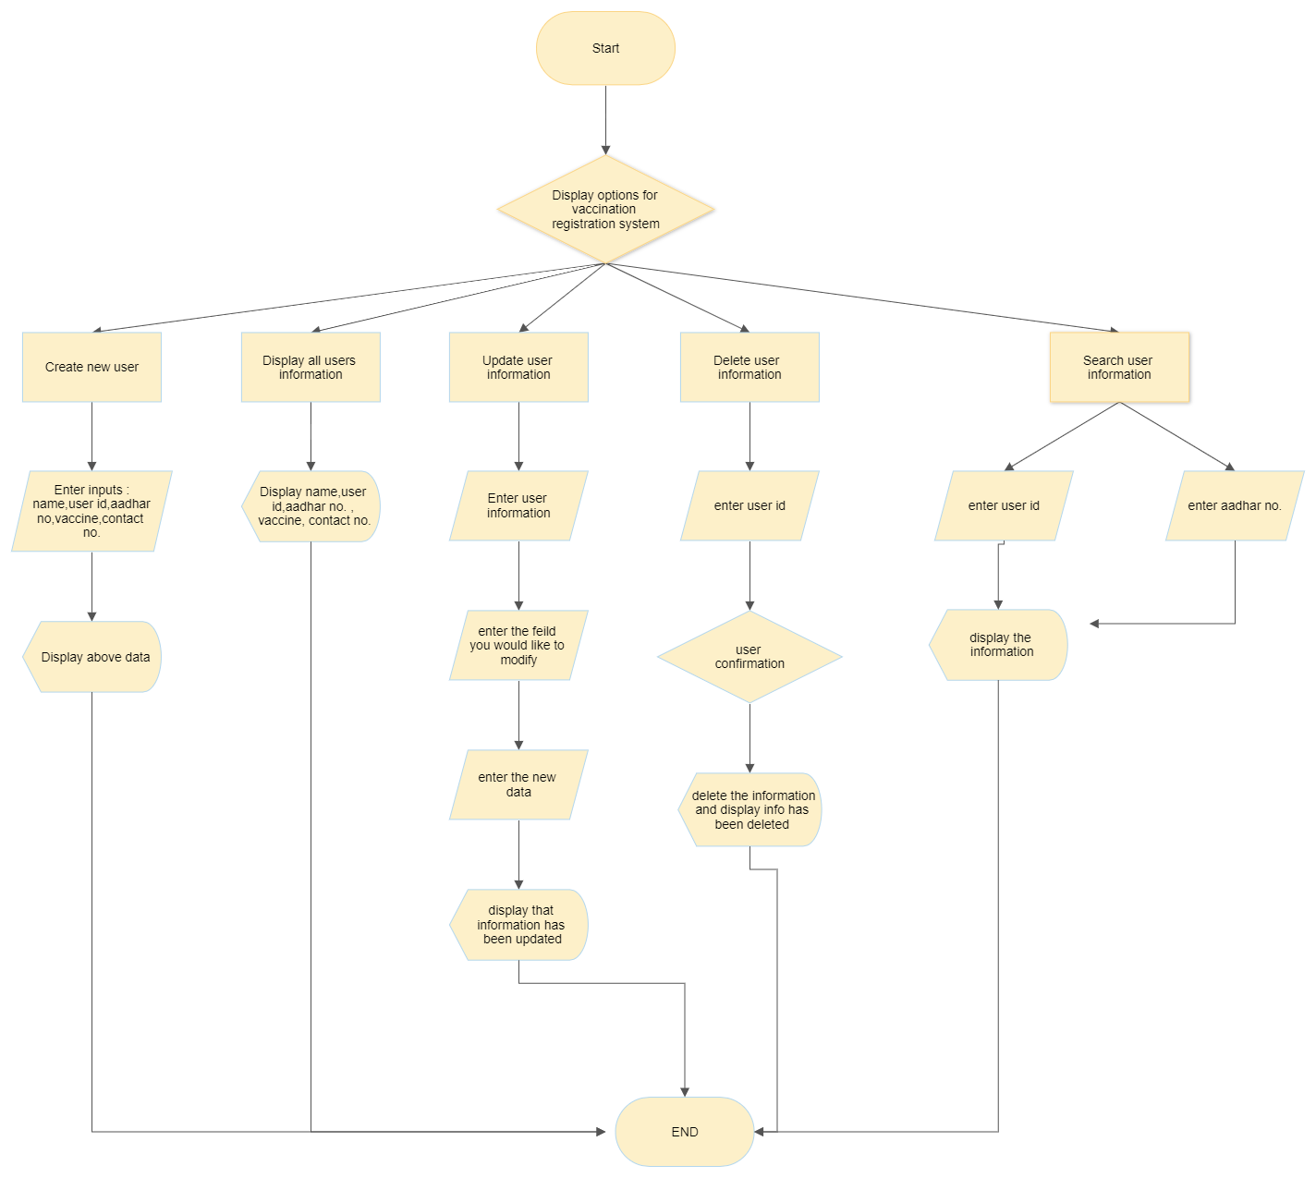

Algorithm

Step 1 : Start

Step 2 : Display the options for vaccine registration system

Step 2A: Create new user

Step 2 B: Display all users information

Step 2 C: Update user information

Step 2 D: Delete user information

Step 2 E: Search user information

Step 3 : Under "Create new user”

Step 3A: Get the following inputs from user: Name, User ID, Aadhar number , vaccine taken , contact number

Step 3B: Display all the inputs entered by the user in Step 3A

Step 4 : Under "Display all users information”

Step 4A: Displays the following information for existing users: Name, user ID, Aadhar number, vaccinetaken, contactnumber

Step5: Under"Update user information”

Step 5 A: Enter user ID

Step 5B: Enter the field you would like to modify: Name,userID ,Aadhar number, vaccine taken, contact number

Step 5 C: Enter the new data for the above selectedfield

Step 5 D: Displays that the information has been updated

Step 6 : Under "Delete user information”

Step 6 A: Enter user ID

Step 6B: Asks confirmation for deleting all the information

Step 6C: Deletes information if the confirmation is given elsedoes not delete information

Sep 7 :Under "Search user information”

Step 7A:Enter either of the following inputs : User ID or Aadharnumber

Step 7 B: Displays the following information: Name, user ID,Aadhar number, vaccine taken

Program

#include <stdio.h>

#include <string.h>

#include <conio.h>

#include <stdlib.h>

typedef struct User

{

char UserName[50];

char UserId[15];

char UserAadhar[20];

char Vaccine_name[100];

char UserContactNum[15];

} User;

void createAccount();

void displayInfo();

void updateInfo();

void deleteInfo();

void searchInfo();

int main()

{

char option;

while (option != '0')

{

system("cls");

printf("\t\t====== Vaccine Registration System ======\n");

printf("\n\t\t\t1. Create User Account");

printf("\n\t\t\t2. Display All Users Information");

printf("\n\t\t\t3. Update User Information");

printf("\n\t\t\t4. Delete User Information");

printf("\n\t\t\t5. Search User Information");

printf("\n\t\t\t0. Exit");

printf("\n\n\n\t\t\tEnter Your Option: ");

scanf(" %c", &option);

switch (option)

{

case '1':

createAccount();

break;

case '2':

displayInfo();

break;

case '3':

updateInfo();

break;

case '4':

deleteInfo();

break;

case '5':

searchInfo();

break;

case '0':

printf("\n\t\t\t====== Thank You ======");

break;

default:

printf("\n\t\t\tInvalid Option, Please Enter Right Option !\n");

}

}

return 0;

}

void createAccount()

{

FILE *fileOne = fopen("UserInfo.bin", "ab+");

if (fileOne == NULL)

{

printf("\n\t\t\tError !\n");

}

User Info;

system("cls");

printf("\t\t\t====== Create User Account ======\n");

printf("\n\t\t\tEnter User's Name : ");

getchar();

gets(Info.UserName);

printf("\t\t\tEnter User's ID : ");

gets(Info.UserId);

printf("\t\t\tEnter User's Aadhaar : ");

gets(Info.UserAadhar);

printf("\t\t\tEnter User's Vaccine : ");

gets(Info.Vaccine_name);

printf("\t\t\tEnter User's Contact Number : ");

gets(Info.UserContactNum);

fwrite(&Info, sizeof(Info), 1, fileOne);

printf("\n\n\t\t\tInformations have been stored sucessfully\n");

printf("\n\n\t\t\tEnter any keys to continue.......");

getch();

fclose(fileOne);

}

void displayInfo()

{

FILE *fileOne = fopen("UserInfo.bin", "rb");

if (fileOne == NULL)

{

printf("\n\t\t\tError !\n");

}

User Info;

system("cls");

printf("\t\t\t\t====== All Users Information ======\n");

printf("\n\n\t\t%-20s%-13s%-10s%-25s%-15s%", "Name", "ID", "Aadhaar", "Vaccine", "Contact");

printf("\t\t----------------------------------------------------------------------------------------");

while (fread(&Info, sizeof(Info), 1, fileOne) == 1)

{

printf("\n\n\t\t%-20s%-13s%-10s%-25s%-15s%", Info.UserName, Info.UserId, Info.UserAadhar, Info.Vaccine_name, Info.UserContactNum);

}

printf("\n\n\t\tEnter any keys to continue.......");

getch();

fclose(fileOne);

}

void updateInfo()

{

FILE *fileOne = fopen("UserInfo.bin", "rb");

FILE *temp = fopen("temp.bin", "wb");

User Info, tempInformation;

int choice, flag = 0;

if (fileOne == NULL || temp == NULL)

{

printf("\n\t\t\tError !\n");

}

system("cls");

printf("\t\t\t\t====== Update Users Information ======\n");

printf("\n\t\t\tEnter User's ID : ");

getchar();

gets(tempInformation.UserId);

while (fread(&Info, sizeof(Info), 1, fileOne) == 1)

{

if (strcmp(Info.UserId, tempInformation.UserId) == 0)

{

flag++;

printf("\n\t\t\tChoose your option :\n\t\t\t1.Update User Name\n\t\t\t2.Update User ID\n\t\t\t3.Update User Aadhaar\n\t\t\t4.Update User Contact No.");

printf("\n\n\t\t\tEnter Your Option : ");

scanf("%d", &choice);

if (choice == 1)

{

printf("\n\t\t\tEnter User's Name to Update: ");

getchar();

gets(tempInformation.UserName);

strcpy(Info.UserName, tempInformation.UserName);

fwrite(&Info, sizeof(Info), 1, temp);

printf("\n\n\t\t\tUpdated successfully!\n\n");

}

else if (choice == 2)

{

printf("\n\t\t\tEnter User's Aadhaar to Update: ");

getchar();

gets(tempInformation.UserAadhar);

strcpy(Info.UserAadhar, tempInformation.UserAadhar);

fwrite(&Info, sizeof(Info), 1, temp);

printf("\n\n\t\t\tUpdated successfully!\n\n");

}

else if (choice == 3)

{

printf("\n\t\t\tEnter User's Vaccine to Update: ");

getchar();

gets(tempInformation.Vaccine_name);

strcpy(Info.Vaccine_name, tempInformation.Vaccine_name);

fwrite(&Info, sizeof(Info), 1, temp);

printf("\n\n\t\t\tUpdated successfully!\n\n");

}

else if (choice == 4)

{

printf("\n\t\t\tEnter User's Contact No. to Update: ");

getchar();

gets(tempInformation.UserContactNum);

strcpy(Info.UserContactNum, tempInformation.UserContactNum);

fwrite(&Info, sizeof(Info), 1, temp);

printf("\n\n\t\t\tUpdated successfully!\n\n");

}

else

{

printf("\n\t\t\tInvalid Option.");

fwrite(&Info, sizeof(Info), 1, temp);

}

}

else

{

fwrite(&Info, sizeof(Info), 1, temp);

}

}

fclose(fileOne);

fclose(temp);

remove("UserInfo.bin");

rename("temp.bin", "UserInfo.bin");

if (flag == 0)

{

printf("\n\t\t\tUser Id is not found");

}

printf("\n\n\t\t\tEnter any keys to continue.......");

getch();

}

void deleteInfo()

{

FILE *fileOne = fopen("UserInfo.bin", "rb");

FILE *temp = fopen("temp.bin", "wb");

User Info, tempInformation;

int choice, flag = 0;

if (fileOne == NULL || temp == NULL)

{

printf("\n\t\t\tError !\n");

}

system("cls");

printf("\t\t\t\t====== Delete User Information ======\n");

printf("\n\t\t\tEnter User's ID : ");

getchar();

gets(tempInformation.UserId);

while (fread(&Info, sizeof(Info), 1, fileOne) == 1)

{

if (strcmp(Info.UserId, tempInformation.UserId) == 0)

{

flag++;

printf("\n\t\t\tAre you sure to delete ??\n\t\t\t\t1.Yes\n\t\t\t\t2.Back\n\t\t\t\tEnter Your Option : ");

scanf("%d", &choice);

if (choice == 1)

{

printf("\n\n\t\t\tInformation has been deleted successfully!\n\n");

}

else if (choice == 2)

{

fwrite(&Info, sizeof(Info), 1, temp);

}

else

{

printf("\n\t\t\tInvalid Option");

fwrite(&Info, sizeof(Info), 1, temp);

}

}

else

{

fwrite(&Info, sizeof(Info), 1, temp);

}

}

fclose(fileOne);

fclose(temp);

remove("UserInfo.bin");

rename("temp.bin", "UserInfo.bin");

if (flag == 0)

{

printf("\n\t\t\tUser Id is not found");

}

printf("\n\n\t\t\tEnter any keys to continue.......");

getch();

}

void searchInfo()

{

FILE *fileOne = fopen("UserInfo.bin", "rb");

User Info;

int choice, flag = 0;

char UserID[20], UserAadhar[20];

if (fileOne == NULL)

{

printf("\n\t\t\tError !\n");

}

system("cls");

printf("\t\t\t\t====== Search User Information ======\n");

printf("\n\t\t\tChoose your option :\n\t\t\t1.Search by User ID\n\t\t\t2.Search by Aadhaar");

printf("\n\n\t\t\tEnter Your Option : ");

scanf("%d", &choice);

if (choice == 1)

{

system("cls");

printf("\t\t\t\t====== Search User Information ======\n");

printf("\n\n\t\t\tEnter User ID : ");

getchar();

gets(UserID);

while (fread(&Info, sizeof(Info), 1, fileOne) == 1)

{

if (strcmp(Info.UserId, UserID) == 0)

{

flag++;

printf("\n\t\t\tUser Name : %s\n\t\t\tUser ID : %s\n\t\t\tUser Aadhaar : %s\n\t\t\tUser Vaccine : %s\n\t\t\tUser Contact No. : %s", Info.UserName, Info.UserId, Info.UserAadhar, Info.Vaccine_name, Info.UserContactNum);

}

}

if (flag == 0)

{

printf("\n\t\t\tUser Id is not found");

}

}

else if (choice == 2)

{

system("cls");

printf("\t\t\t\t====== Search User Information ======\n");

printf("\n\n\t\t\tEnter User Aadhaar : ");

getchar();

gets(UserAadhar);

printf("\n\n\t\t%-20s%-13s%-10s%-25s%-15s%-s\n", "Name", "ID", "Dept.", "Address", "Contact");

printf("\t\t----------------------------------------------------------------------------------------");

while (fread(&Info, sizeof(Info), 1, fileOne) == 1)

{

if (stricmp(Info.UserAadhar, UserAadhar) == 0)

{

flag++;

printf("\n\n\t\t%-20s%-13s%-10s%-25s%-15s%", Info.UserName, Info.UserId, Info.UserAadhar, Info.Vaccine_name, Info.UserContactNum);

}

}

if (flag == 0)

{

printf("\n\t\t\tUser Id is not found");

}

}

else

{

printf("\n\t\t\tInvalid Option");

}

fclose(fileOne);

printf("\n\n\n\t\t\tEnter any keys to continue.......");

getch();

}

OUTPUT SCREEN

